**Project report: Nussinov Folding Algorithm for RNA Secondary Structure Prediction**

Sanket Achari UFID: 71096329

Rushikesh Gawali UFID: 83304331

**Algorithm:**

Nussinov’s algorithm compares given sequence of RNA to itself in order to predict the secondary structure. Dynamic programming is used to calculate the maximum number of matching pairs in the sequence and predict the structure which will be 2D representation of RNA.

Allowed pairs: **A – U & G – C**

**Objective:**

Identify maximum number of non-crossing pairs in a given RNA sequence and trace back the sequence to predict the secondary structure of RNA (folding of a RNA sequence)

**Dynamic Programming**:

Let S be a given RNA sequence consisting characters A, C, G, U

Let δ(i, j) = 1 if xi and xj are complementary i.e. they form a pair

= 0 otherwise

Initialization:

dp(i, i-1) = 0 for i = 2 to N

dp(i, i) = 0 for i = 1 to N

Recursion:

dp(i, j) = max { dp(i+1, j),

dp(i, j-1),

dp(i + 1, j -1) + δ(i, j)

max( dp(i, k) + dp(k + 1, j)) where i < k < j

}

Result:

dp(1, N) gives the maximum number of paired bases in the given RNA sequence.

**Backtracking**:

We backtrack from dp(1, N) position till we get diagonal position at which dp(i,i) is zero.

Backtrack(1, N) will give the secondary structure of RNA sequence.

*Backtrack*(i, j):

if i == j

return S(i)

if i > j

return “”

if dp(i, j) == dp(i + 1, j)

return S(i) + *Backtrack*(i + 1, j)

if dp(i, j) == dp(i, j - 1)

return *Backtrack*(i , j - 1) + S(j)

if S(i) == S(j) && dp(i, j) == dp(i + 1, j - 1) + δ(i, j)

return “(” S(i) + *Backtrack*(i + 1 , j - 1) + S(j) + “)”

if (dp(i, j) == dp(i, k) + dp(k + 1, j)) for every i < k < j  
 return *Backtrack*(i, k) + *Backtrack*(k + 1, j);

return “Backtracking failed”

**Example**

1. Input RNA sequence: GGGAAAUCC

Output: Matched pairs: 3

Secondary Structure after folding: G(G(GAA(AU)C)C)

1. Input RNA sequence: AAAUCCCAGGA

Output: Matched pairs: 3

Secondary Structure after folding: AAA(UC(C(CAG)G)A)

1. Input RNA sequence: AAAUCCCAGGAU

Output: Matched pairs: 4

Secondary Structure after folding: AA(A(UC(C(CAG)G)A)U)

**Run Instructions:**

Compile: javac –cp . Nussinov.java

Run: java –cp . Nussinov AAAUCCCAGGA

Ouput:

Matched pairs: 3

Secondary Structure after folding: AAA(UC(C(CAG)G)A)

Visualization of above example:

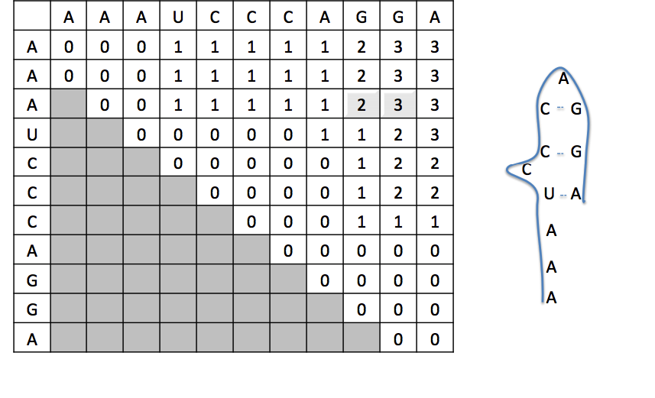

Complexity:

Space complexity: O(n2)

Time complexity along with backtrack: O(n2)

Workload Distribution:

Sanket: He worked on the implementation of Nussinov algorithm in Java. Implementation involved understanding, coding, and verifying the results.

Rushikesh: He provided the idea of this project. Also helped in the analysis of algorithm, results and calculation of the complexity.

Conclusion: